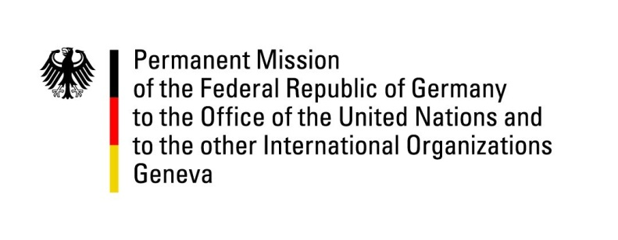

United Nations Human Rights Council
27th Session of the UPR Working Group

Geneva, 10 May 2016

---
German recommendations to
South Africa

Mr. President,

Germany commends South Africa’s progress in reducing child and maternal mortality and recommends:

- Ensure the unconditional access to primary, secondary and tertiary education for all groups of society, irrespective of their socio-economic situation, ethnic background or gender.

- Ratify the OP-CAT and ensure the Independent Police Investigative Directorate investigates all allegations of torture.

- Ratify the Convention on the Status of Stateless Persons, Convention on the Reduction of Statelessness and the International Convention for the Protection of All Persons from Enforced Disappearance.

- Take all necessary measures to end sexual and gender-based violence, especially by developing adequate gender sensitive training programs for law enforcement agencies, the national prosecuting authority and judicial officers, and by adopting specific legislation addressing the practice of ukuthwala (child marriage).

Thank you.

Advance questions:

- In view of the tragic events in the wake of the relocation process of persons with psychosocial and intellectual disabilities from Life Healthcare Esidimeni hospitals: which steps are taken on all levels to ensure the rights of persons with disabilities, in line with the Convention on the Right of Persons with Disabilities?

- How does the government try to balance business interests and Human Rights and to implement the UN Guiding Principles on Business and Human Rights, for example in the case of water pollution caused by mining companies?

- As one of the main countries of destination for refugees and asylum seekers- and recognizing South Africa’s important efforts in this field - which concrete legislative steps does the government of South Africa envisage in order to further promote the integration of migrants into the workforce and respect their basic rights? What are the specific improvements implied in the White Paper on International Migration and how does the government of South Africa ensure it is consistent with international human rights law standards?

- In which ways does the government promote the right to privacy, especially with regard to transparency about the use of covert surveillance?

